User Profile Creation
Users  - Primary  - Kolavo User  - Secondary  - Community page creators (admins) | Phase 1
Intended Outcome
- Ensure every Kolavo user creates a basic personal profile with complete identity information, so that every account is known to be a real, accountable person.
- Make it easy for community admins to contact and verify applicant identities using registered WhatsApp numbers, supporting a thorough and trustworthy membership approval process.
- Strengthen trustworthiness and safety across Kolavo communities by minimizing fake or anonymous accounts.
Links
- …
- …
- …
- …
- …

Introduction

Product Requirement
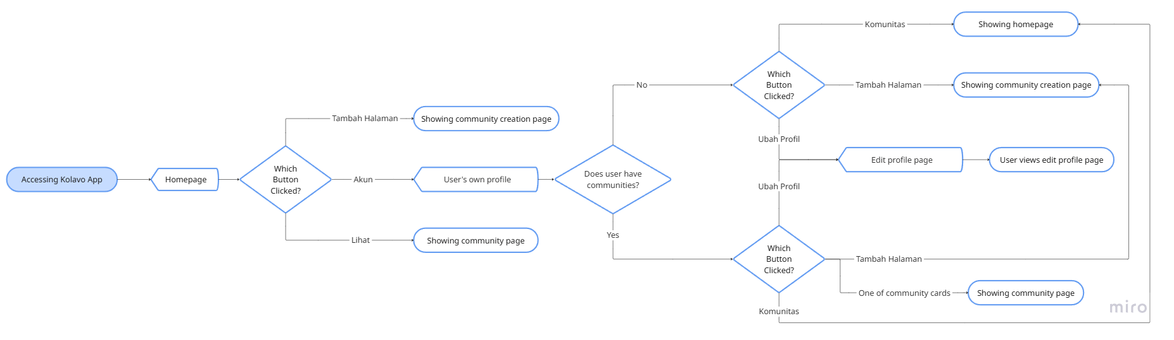
Editing User's Own Profile Flow

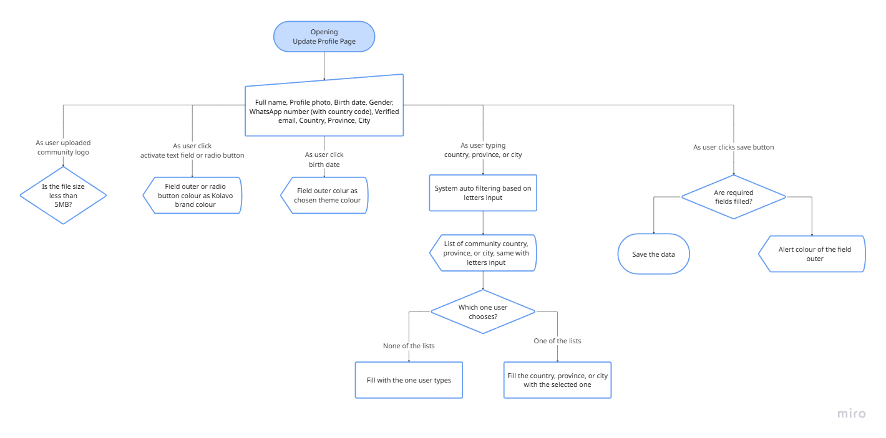
Interaction Flow of Updating Profile

No | User story | Scope | Acceptance Criteria
1 | As a new Kolavo user, I want to create my account with a complete and verifiable identity, so that communities know I am a real person and not a fake or anonymous profile. | User Profile Creation Form | - New users are required to complete a profile form before joining to any or creating a community.  - Form asks for:  - Full name  - Profile photo  - Birth date  - Gender  - WhatsApp number (with country code)  - Verified email  - Country  - Province  - City  - All fields are required  - Email must be confirmed  - Users cannot proceed to apply/create without completing profile creation.
2 | As a Kolavo user, I want to input my WhatsApp number with country code, so admins can verify my identity and contact me easily if my application needs review. | WhatsApp Number Input | - WhatsApp number field requires input in international format.  - Number is validated for format and length.  - WhatsApp number is only visible to community admins.  - Users cannot complete a profile without a valid WhatsApp number with country code.  - The number is stored for use as an admin contact method.
3 | As a Kolavo user, I want to easily input my location, so that my real-world context is visible for community verification and participation. | Domicile (Location) Field | - Domicile is input as a free text field  - City  - Province  - Country  - Value is stored as saved, and the system saves new/existing entries for future use.  - Domicile is visible to community admins during review and to members once accepted according to privacy rules.  - Domicile data is not restricted to a pre-set dropdown; user inputs are flexible but may be cleaned/suggested for spelling or location hints.
4 | As a Kolavo user, I want to know which information will be shared with admins and which will be public after joining a community, so that my privacy is protected and I understand how my data is used. | Data Privacy Info Display | - On the profile creation/edit page, each field is labeled or previewed as “visible to admins only” or “public to accepted members.”  - WhatsApp number is clearly labeled as admin-only.  - Profile page (after completion) displays only fields marked as public.
5 | As a community organizer, I want to verify applicants’ identity using reliable and direct contact methods, so I can confidently accept real people and filter out suspicious or incomplete profiles. | Profile Data for Admin Verification | - Admins reviewing applicants have access to applicants’ profile photo, full name, WhatsApp number (including full country code), email, and domicile.  - Product supports admin workflows for reaching out to WhatsApp for verification if needed (e.g. click-to-start chat).
6 | As product manager, I want users to know that canceling an update profile hinders them from joining/creating communities, so they are willing to update their profile. | Profile Completion Required Dialog & Barrier | - On the profile update page, if a user tries to cancel, exit, or leave the page without saving or finishing required fields, a modal appears with a clear warning.  - Warning explanation makes it explicit that updating profile is mandatory for community access.  - Modal gives user two options:  - Proceed to update  - Exit  - Any attempt to join/create communities with incomplete profile triggers similar warning.  - Tracking is enabled so PM can see how many users chose to exit.  - No community registration or creation permitted until profile is complete.

Design Requirement
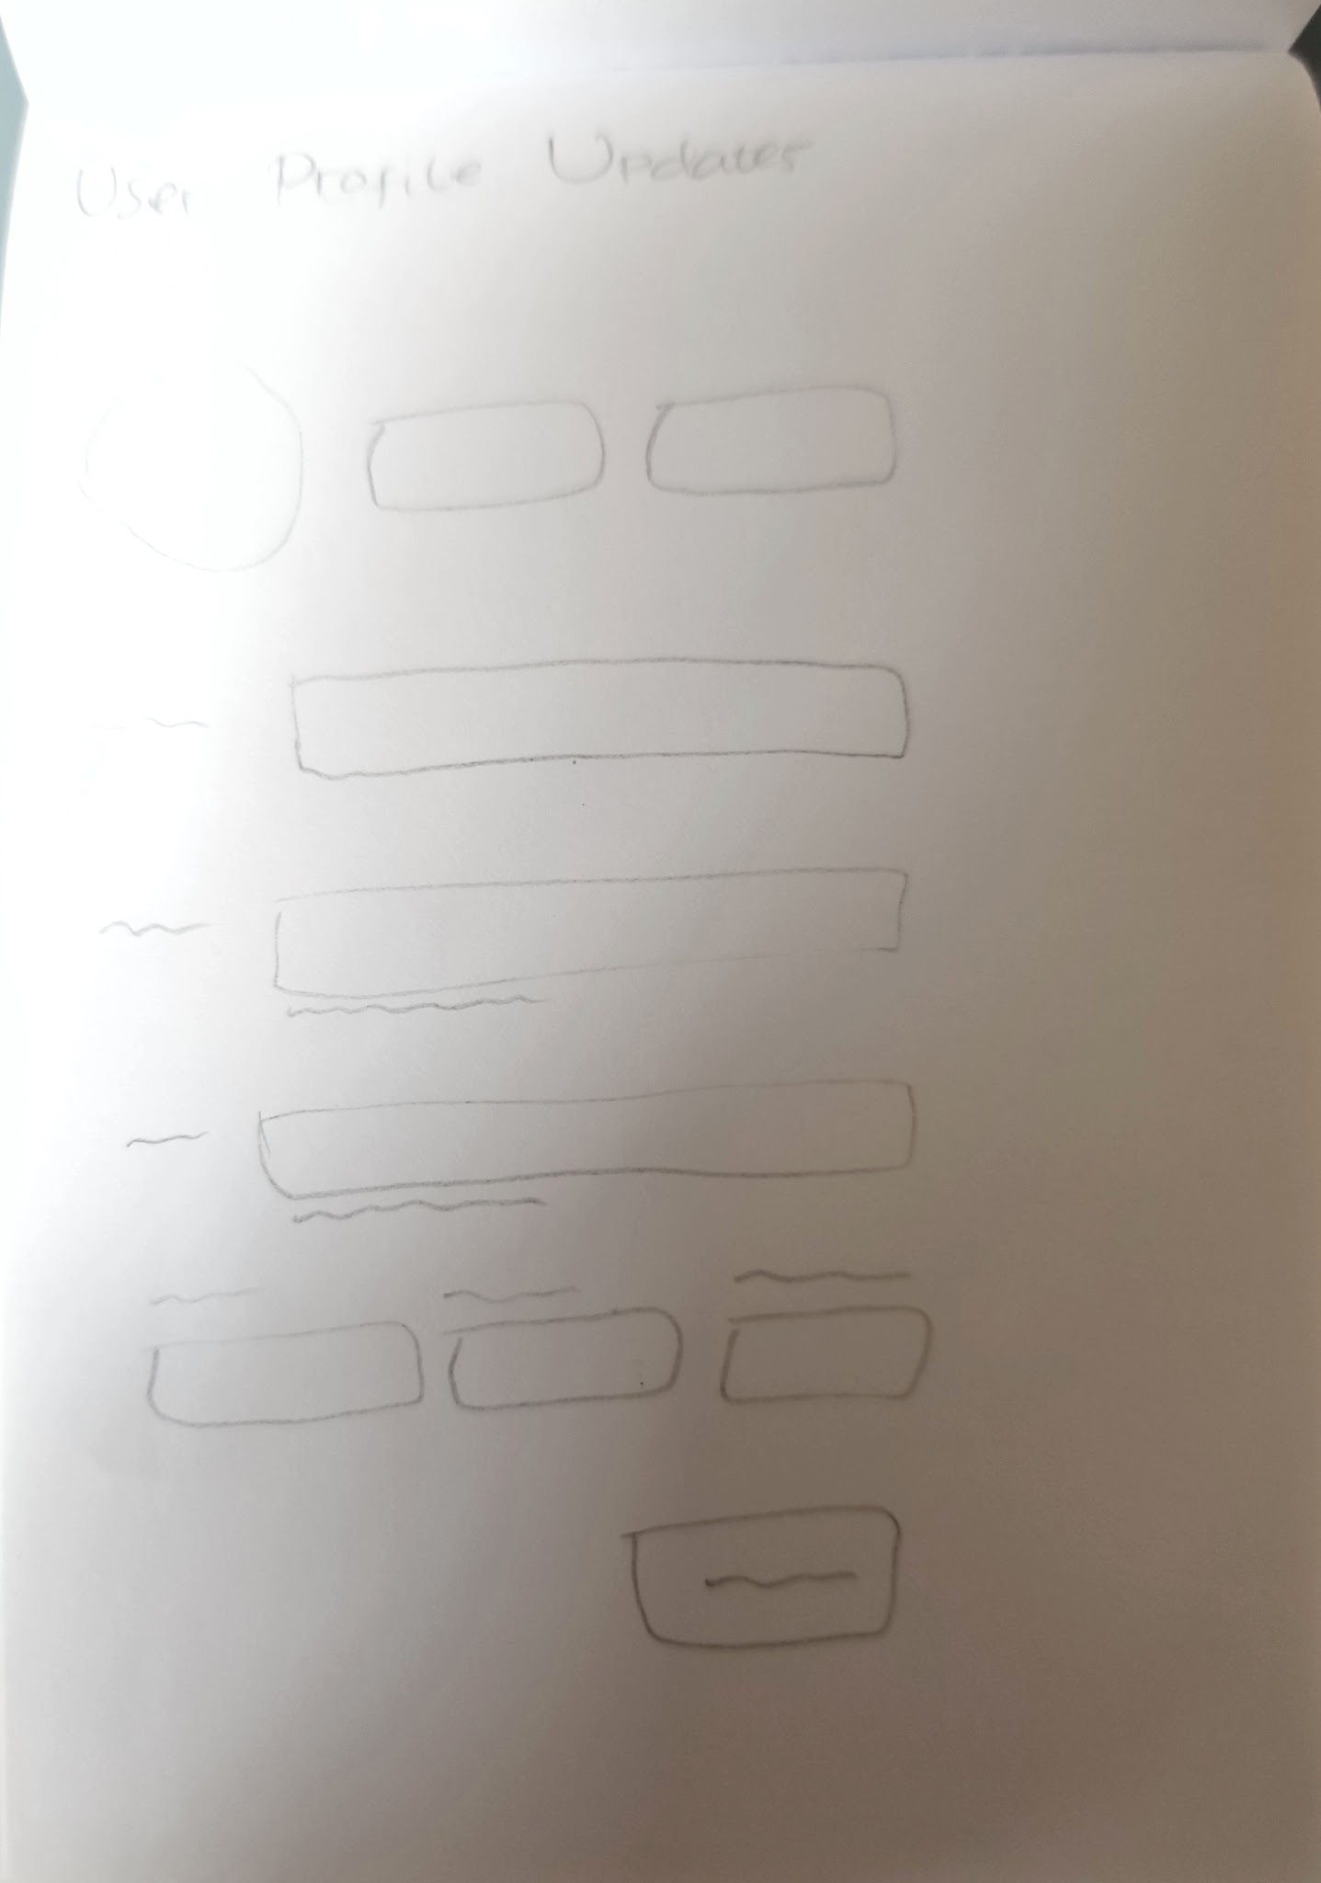

Breadcrumbs
Design Intent | To ease users knowing where they are and how they can go back to previous page
Content / Copy | - Mobile: < Ubah Profil  - PC: [fullname] > Ubah Profil
Visual Requirement
Interaction Behavior | - Click < directs to previous page  - If user’s profile not completed yet, show Blocker Modal
Acceptance Criteria

Profile Update Page
Design Intent | To increase user awareness about the function of the page and the data they provide
Content / Copy | - Header title: Update Profil  - Subheader: Agar mudah dikenali dan dipercaya di setiap komunitas yang kamu ikuti.
Visual Requirement
Interaction Behavior
Acceptance Criteria

Profile Update Form
Design Intent | To allow users providing their personal information so they can increase their profile accountability
Content / Copy | - Label:  - Full name: Nama Lengkap  - Profile photo: Foto Profil  - Birth date: Tanggal Lahir  - Gender: Jenis Kelamin  - WhatsApp number: Nomor Whatsapp  - Verified email: Alamat E-mail  - Country: Negara  - Province: Provinsi  - City: Kota  - Placeholder:  - Birth date: DD/MM/YYYY  - Gender radio button:  - Perempuan  - Laki-laki  - WhatsApp number (with country code) field text: +6281230000000  - Helper text:  - Fullname: Hanya ditampilkan ke admin komunitas kamu.  - Birth date: Info ini tidak akan dipublikasikan.  - Gender: Info ini tidak akan dipublikasikan.  - WhatsApp number (with country code): Hanya ditampilkan ke admin komunitas kamu.  - Verified email: Info ini tidak akan dipublikasikan.  - Button:  - Save: Simpan
Visual Requirement
Interaction Behavior
Acceptance Criteria

Blocker modal
Design Intent | To encourage users continue updating their profile so they can create/join communities
Content / Copy | - Illustration: not known illustration  - Title: Kamu belum dikenali  - Body: Lengkapi profil mu agar kamu bisa dikenali dan membuat atau bergabung komunitas di Kolavo.  - CTA Buttons  - Continue: Lanjutkan Update Profil  - Exit: Nanti Saja
Visual Requirement
Interaction Behavior | - Clicking continue button page remains  - Clicking exit returns to the previous page
Acceptance Criteria

Success modal
Design Intent | To celebrate users milestone of successfully updating their profile and ease them to go back where they started
Content / Copy | - Illustration: celebration illustration  - Title: Profil berhasil diperbarui  - Body: Sekarang kamu bisa dikenali di komunitasmu.  - CTA Buttons: Lanjutkan
Visual Requirement
Interaction Behavior | - Clicking continue returns to the page where update profile is triggered
Acceptance Criteria

Engineering Requirement

Questions

